|  |
| --- |
|  |
| ResCash Prototype |
| For ECS189F Group 2 |
|  |
| **Qingyue Yang** |
| **11/7/2024** |

1. Pages
   1. Page Tree

Home  
Create  
Turnover  
Edit  
Report  
Visual  
Cash

* 1. Home
     1. User Interface

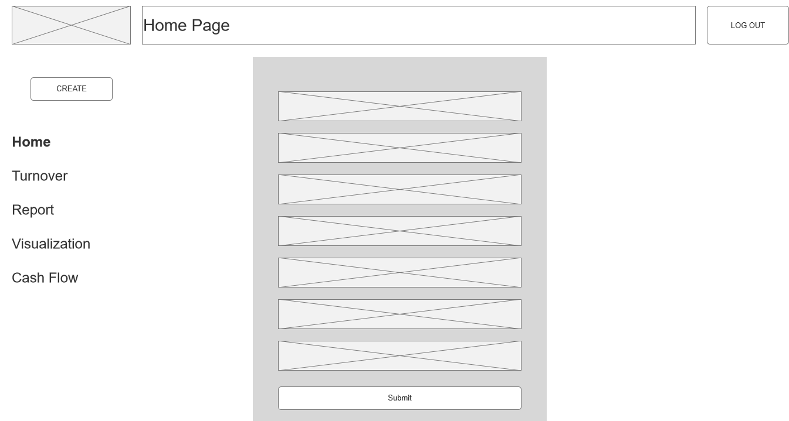

* + 1. Unnamed
       1. State Home
       2. User Interface

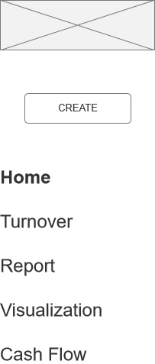

* + - 1. State Cash
      2. User Interface

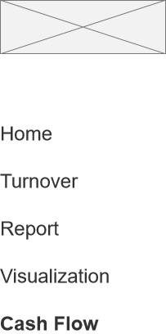

* + - 1. State Visual
      2. User Interface

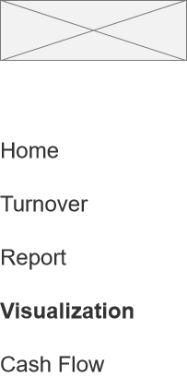

* + - 1. State Turnover
      2. User Interface

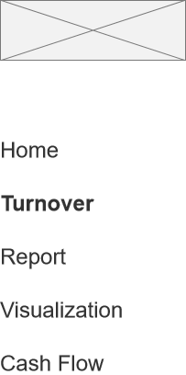

* 1. Create
     1. User Interface

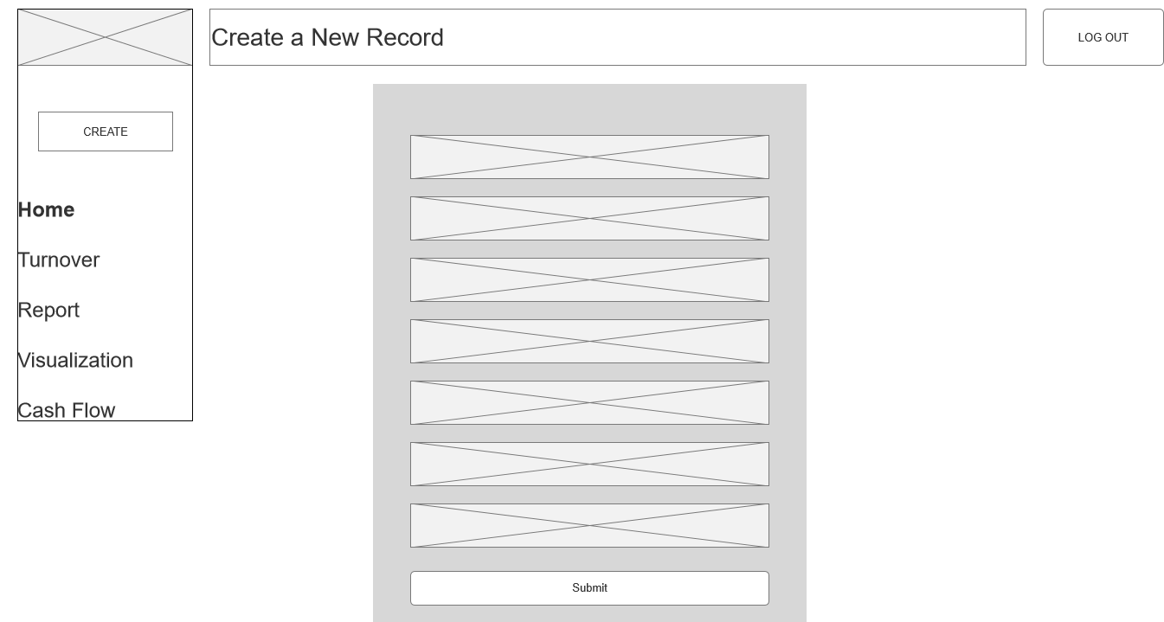

* + 1. Unnamed
       1. State Home
       2. User Interface

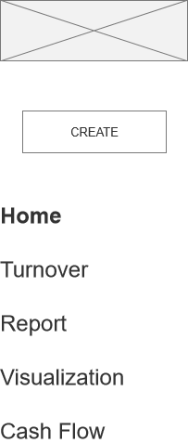

* + - 1. State Cash
      2. User Interface



* + - 1. State Visual
      2. User Interface



* + - 1. State Turnover
      2. User Interface



* 1. Turnover
     1. User Interface

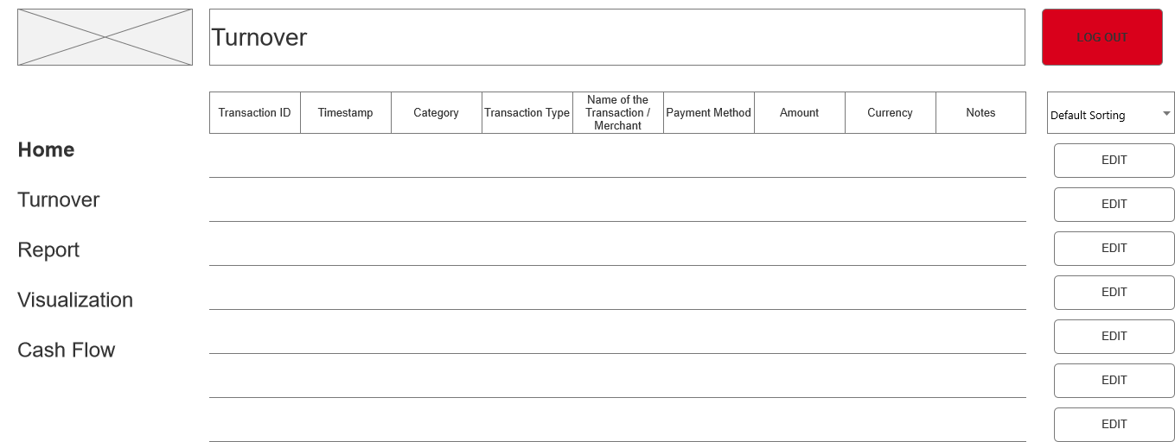

* + 1. Unnamed
       1. State Home
       2. User Interface

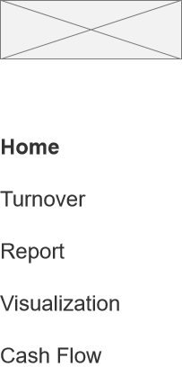

* + - 1. State Cash
      2. User Interface



* + - 1. State Visual
      2. User Interface



* + - 1. State Turnover
      2. User Interface



* 1. Edit
     1. User Interface

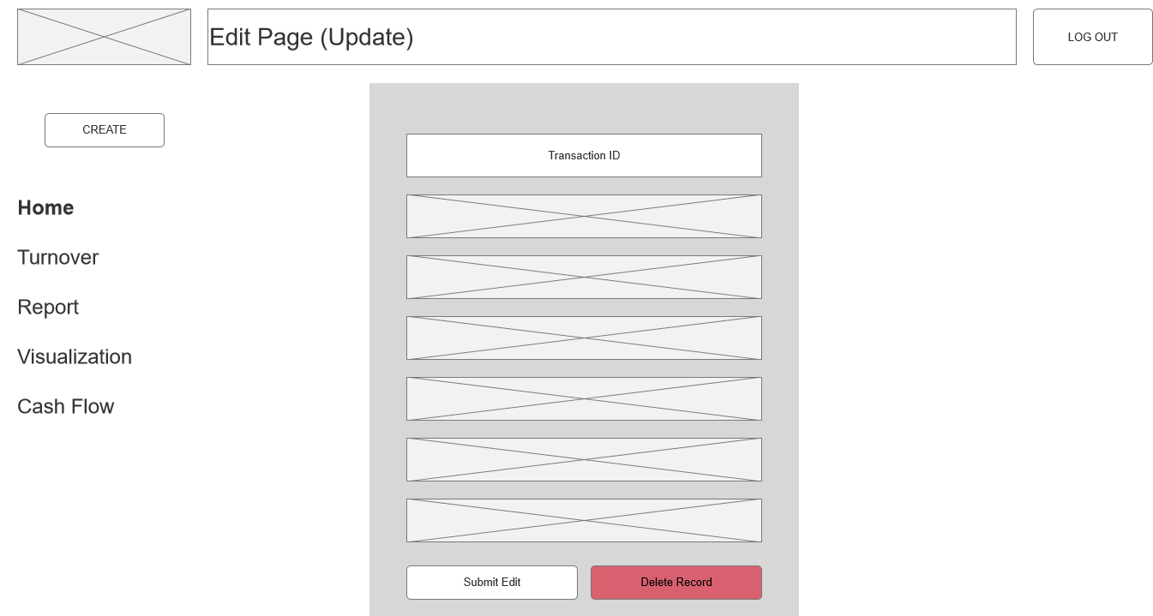

* + 1. Unnamed
       1. State Home
       2. User Interface



* + - 1. State Cash
      2. User Interface



* + - 1. State Visual
      2. User Interface



* + - 1. State Turnover
      2. User Interface



* 1. Report
     1. User Interface

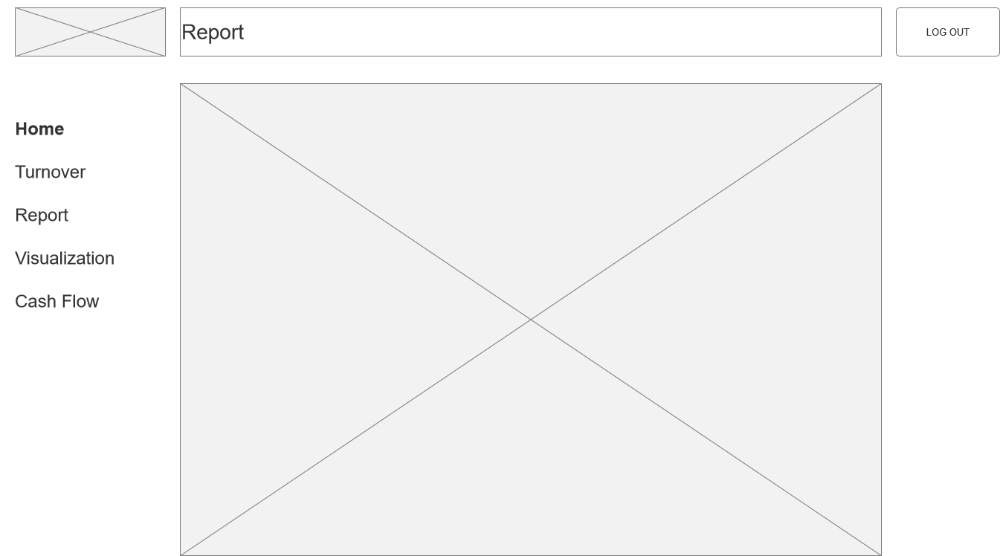

* + 1. Unnamed
       1. State Home
       2. User Interface



* + - 1. State Cash
      2. User Interface



* + - 1. State Visual
      2. User Interface



* + - 1. State Turnover
      2. User Interface



* 1. Visual
     1. User Interface

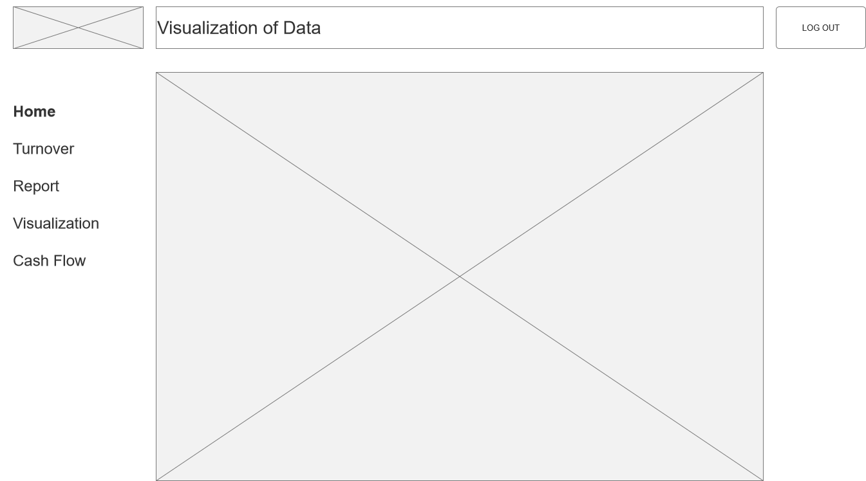

* + 1. Unnamed
       1. State Home
       2. User Interface

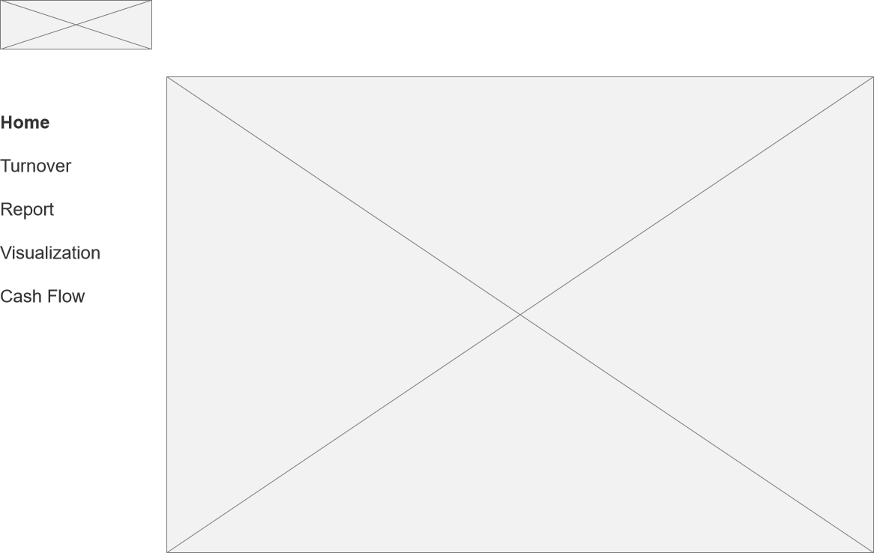

* + - 1. State Cash
      2. User Interface



* + - 1. State Visual
      2. User Interface



* + - 1. State Turnover
      2. User Interface



* 1. Cash
     1. User Interface

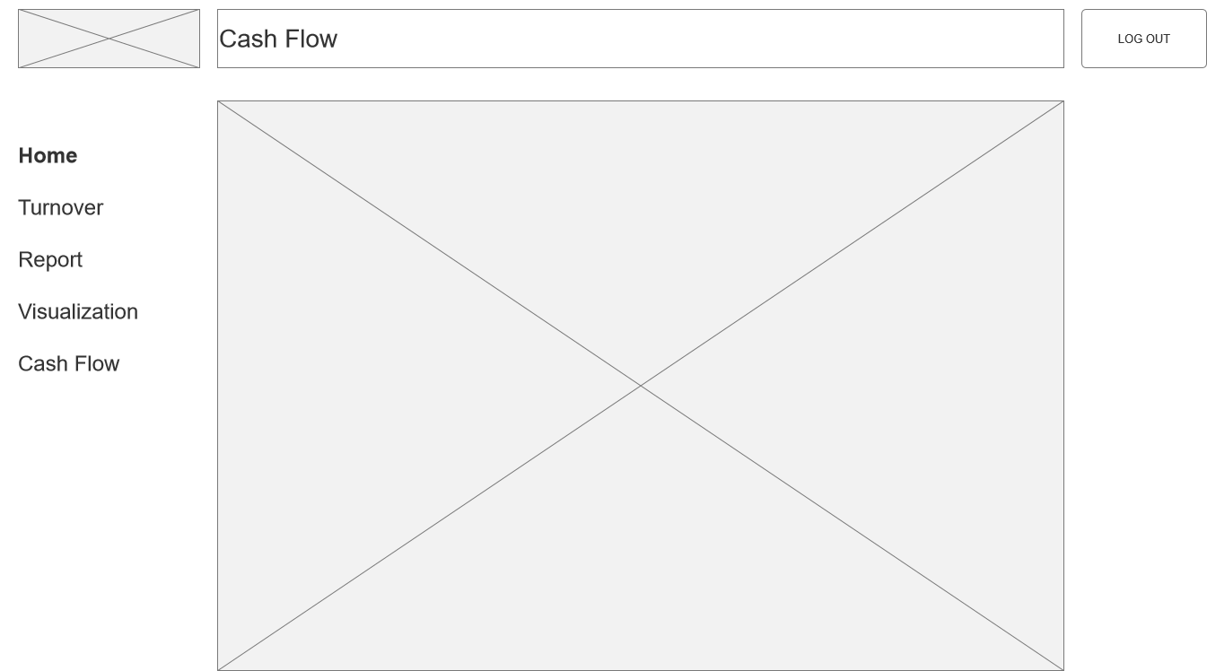

* + 1. Unnamed
       1. State Home
       2. User Interface



* + - 1. State Cash
      2. User Interface



* + - 1. State Visual
      2. User Interface



* + - 1. State Turnover
      2. User Interface



1. Components
   1. Component List

Navigation

* 1. Navigation
     1. User Interface



* + 1. Unnamed
       1. State Home
       2. User Interface



* + - 1. State Cash
      2. User Interface



* + - 1. State Visual
      2. User Interface



* + - 1. State Turnover
      2. User Interface

